

Mawlana Bhashani Science and Technology University
Santosh, Tangail-1902.

Lab Report

Department of Information and Communication Technology

Report No: 02

Report Name: TCP Variants.

Course Title: Wireless and Mobile Communication Lab

Course Code: ICT-4202

Submitted By | Submitted To
Name: S. M Atiqur Rahman  ID: IT-16052  Session: 2015-16  4th Year 2nd Semester  Dept. of Information & Communication Technology,  MBSTU. | Nazrul Islam  Assistant Professor  Dept. of Information & Communication Technology,  MBSTU.

Submission Date: 11-09-2020

Objective:
We have to create a simple dumbbell topology, two client Node1 and Node2 on the left side of the dumbbell and server nodes Node3 and Node4 on the right side of the dumbbell. Let Node5 and Node6 form the bridge of the dumbbell. Use point to point links. Install a TCP socket instance on Node1 that will connect to Node3.install a UDP socket instance on Node2 that will connect to Node4.

Source Code:
#include <fstream>
#include "ns3/core-module.h"
#include "ns3/network-module.h"
#include "ns3/internet-module.h"
#include "ns3/point-to-point-module.h"
#include "ns3/applications-module.h"
using namespace ns3;
NS_LOG_COMPONENT_DEFINE ("FifthScriptExample");
// ===========================================================================
//
// node 0 node 1
// +----------------+ +----------------+
// | ns-3 TCP | | ns-3 TCP |
// +----------------+ +----------------+
// | 10.1.1.1 | | 10.1.1.2 |
// +----------------+ +----------------+
// | point-to-point | | point-to-point |
// +----------------+ +----------------+
// | |
// +---------------------+
// 5 Mbps, 2 ms
//
//
// We want to look at changes in the ns-3 TCP congestion window. We need
// to crank up a flow and hook the CongestionWindow attribute on the socket
// of the sender. Normally one would use an on-off application to generate a
// flow, but this has a couple of problems. First, the socket of the on-off
// application is not created until Application Start time, so we wouldn't be
// able to hook the socket (now) at configuration time. Second, even if we
// could arrange a call after start time, the socket is not public so we
// couldn't get at it.
//
// So, we can cook up a simple version of the on-off application that does what
// we want. On the plus side we don't need all of the complexity of the on-off
// application. On the minus side, we don't have a helper, so we have to get
// a little more involved in the details, but this is trivial.
//
// So first, we create a socket and do the trace connect on it; then we pass
// this socket into the constructor of our simple application which we then
// install in the source node.
// ===========================================================================
//
class MyApp : public Application
{
public:

MyApp ();
virtual ~MyApp();

void Setup (Ptr<Socket> socket, Address address, uint32_t packetSize, uint32_t nPackets, DataRate dataRate);

private:
virtual void StartApplication (void);
virtual void StopApplication (void);

void ScheduleTx (void);
void SendPacket (void);

Ptr<Socket> m_socket;
Address m_peer;
uint32_t m_packetSize;
uint32_t m_nPackets;
DataRate m_dataRate;
EventId m_sendEvent;
bool m_running;
uint32_t m_packetsSent;
};

MyApp::MyApp ()
: m_socket (0),
m_peer (),
m_packetSize (0),
m_nPackets (0),
m_dataRate (0),
m_sendEvent (),
m_running (false),
m_packetsSent (0)
{
}

MyApp::~MyApp()
{
m_socket = 0;
}

void
MyApp::Setup (Ptr<Socket> socket, Address address, uint32_t packetSize, uint32_t nPackets, DataRate dataRate)
{
m_socket = socket;
m_peer = address;
m_packetSize = packetSize;
m_nPackets = nPackets;
m_dataRate = dataRate;
}

void
MyApp::StartApplication (void)
{
m_running = true;
m_packetsSent = 0;
m_socket->Bind ();
m_socket->Connect (m_peer);
SendPacket ();
}

void
MyApp::StopApplication (void)
{
m_running = false;

if (m_sendEvent.IsRunning ())
{
Simulator::Cancel (m_sendEvent);
}

if (m_socket)
{
m_socket->Close ();
}
}

void
MyApp::SendPacket (void)
{
Ptr<Packet> packet = Create<Packet> (m_packetSize);
m_socket->Send (packet);

if (++m_packetsSent < m_nPackets)
{
ScheduleTx ();
}
}

void
MyApp::ScheduleTx (void)
{
if (m_running)
{
Time tNext (Seconds (m_packetSize * 8 / static_cast<double> (m_dataRate.GetBitRate ())));
m_sendEvent = Simulator::Schedule (tNext, &MyApp::SendPacket, this);
}
}

static void
CwndChange (uint32_t oldCwnd, uint32_t newCwnd)
{
NS_LOG_UNCOND (Simulator::Now ().GetSeconds () << "\t" << newCwnd);
}

static void
RxDrop (Ptr<const Packet> p)
{
NS_LOG_UNCOND ("RxDrop at " << Simulator::Now ().GetSeconds ());
}

int
main (int argc, char *argv[])
{
CommandLine cmd;
cmd.Parse (argc, argv);

NodeContainer nodes;
nodes.Create (2);

PointToPointHelper pointToPoint;
pointToPoint.SetDeviceAttribute ("DataRate", StringValue ("5Mbps"));
pointToPoint.SetChannelAttribute ("Delay", StringValue ("2ms"));

NetDeviceContainer devices;
devices = pointToPoint.Install (nodes);

Ptr<RateErrorModel> em = CreateObject<RateErrorModel> ();
em->SetAttribute ("ErrorRate", DoubleValue (0.00001));
devices.Get (1)->SetAttribute ("ReceiveErrorModel", PointerValue (em));

InternetStackHelper stack;
stack.Install (nodes);

Ipv4AddressHelper address;
address.SetBase ("10.1.1.0", "255.255.255.252");
Ipv4InterfaceContainer interfaces = address.Assign (devices);

uint16_t sinkPort = 8080;
Address sinkAddress (InetSocketAddress (interfaces.GetAddress (1), sinkPort));
PacketSinkHelper packetSinkHelper ("ns3::TcpSocketFactory", InetSocketAddress (Ipv4Address::GetAny (), sinkPort));
ApplicationContainer sinkApps = packetSinkHelper.Install (nodes.Get (1));
sinkApps.Start (Seconds (0.));
sinkApps.Stop (Seconds (20.));

Ptr<Socket> ns3TcpSocket = Socket::CreateSocket (nodes.Get (0), TcpSocketFactory::GetTypeId ());
ns3TcpSocket->TraceConnectWithoutContext ("CongestionWindow", MakeCallback (&CwndChange));

Ptr<MyApp> app = CreateObject<MyApp> ();
app->Setup (ns3TcpSocket, sinkAddress, 1040, 1000, DataRate ("1Mbps"));
nodes.Get (0)->AddApplication (app);
app->SetStartTime (Seconds (1.));
app->SetStopTime (Seconds (20.));

devices.Get (1)->TraceConnectWithoutContext ("PhyRxDrop", MakeCallback (&RxDrop));

Simulator::Stop (Seconds (20));
Simulator::Run ();
Simulator::Destroy ();

return 0;
}
OUTPUT :
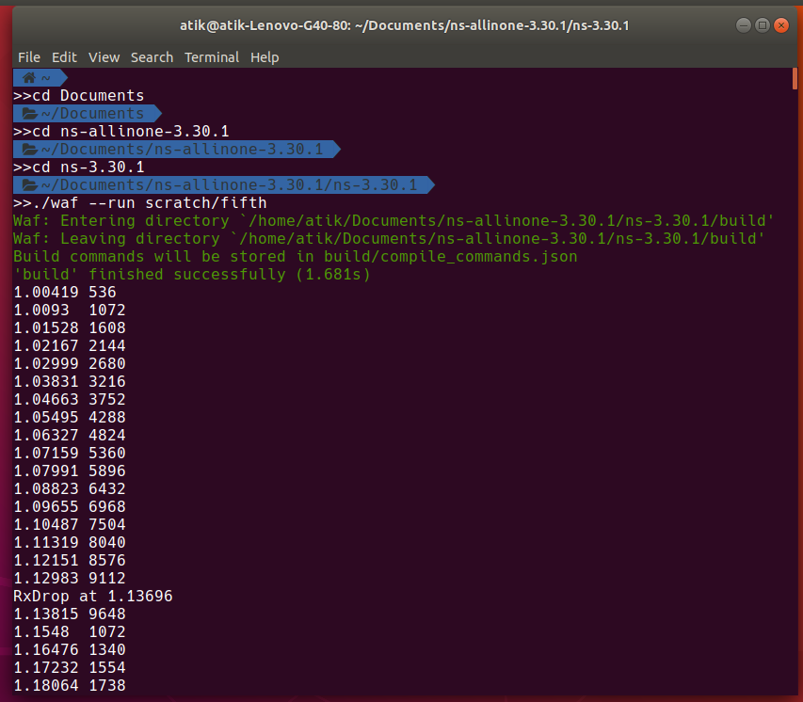

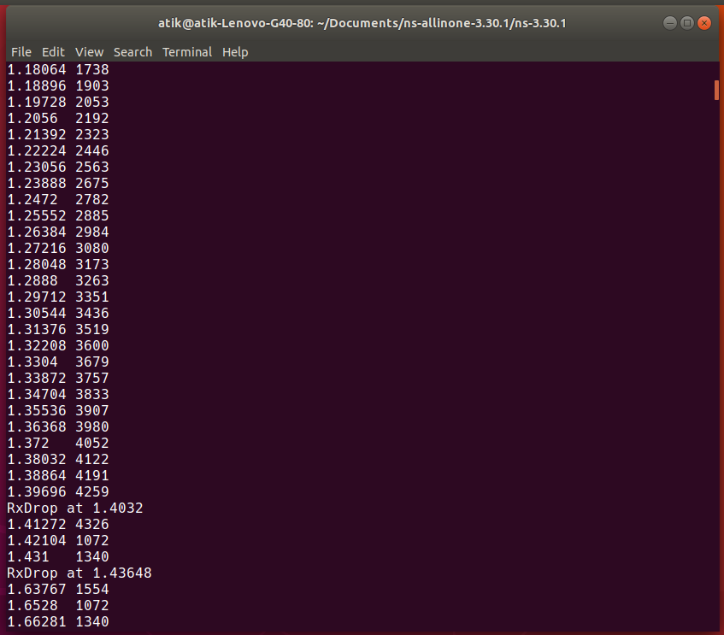
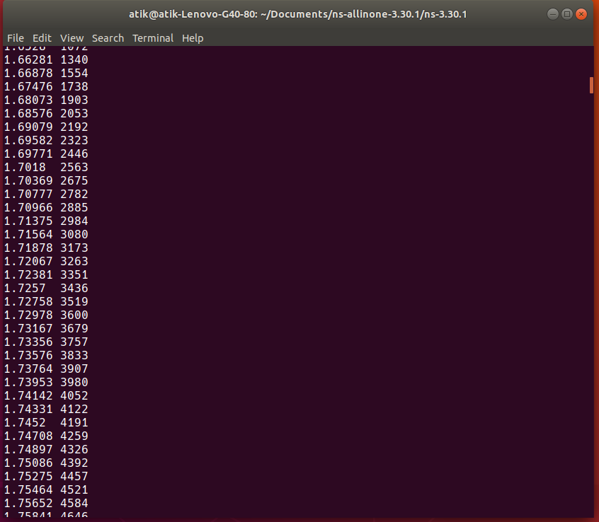
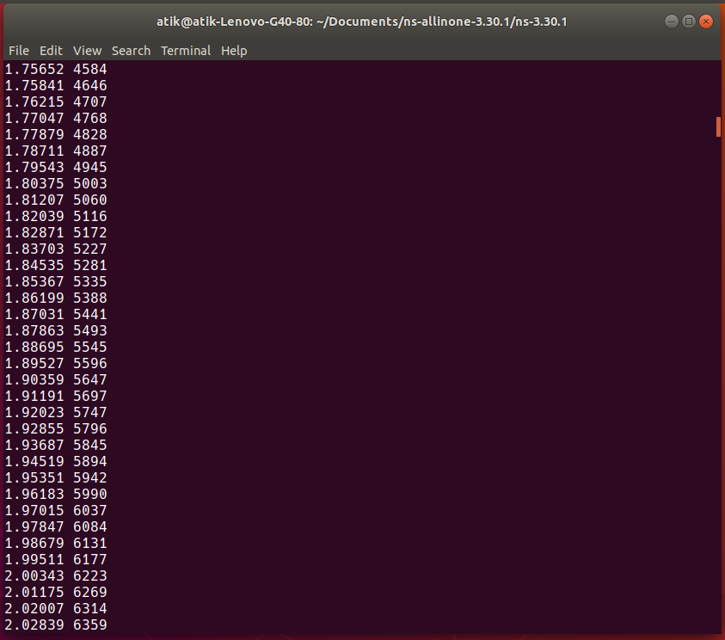
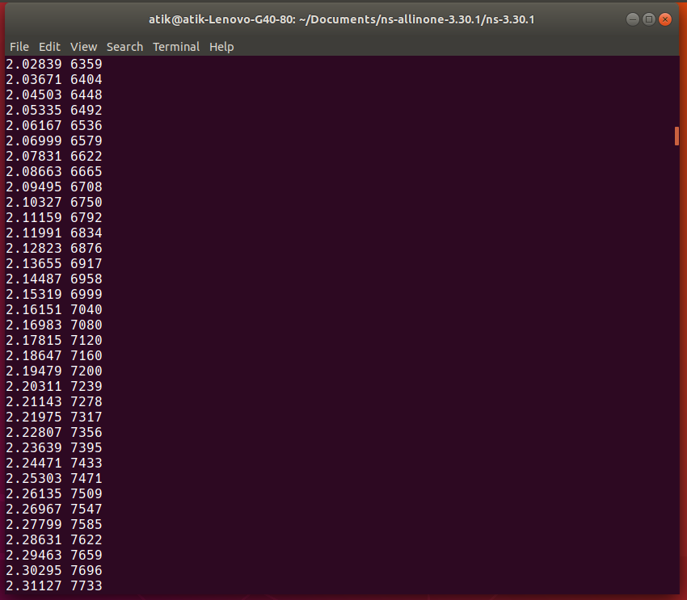

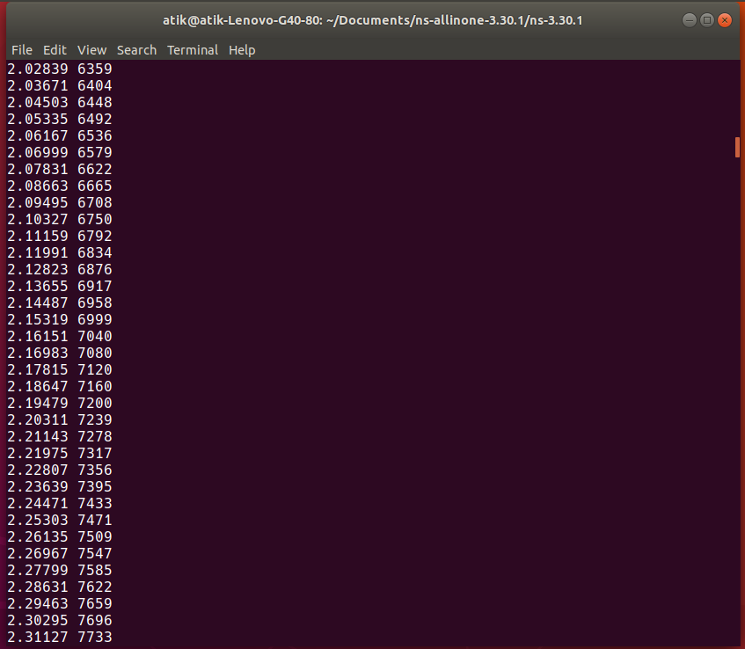
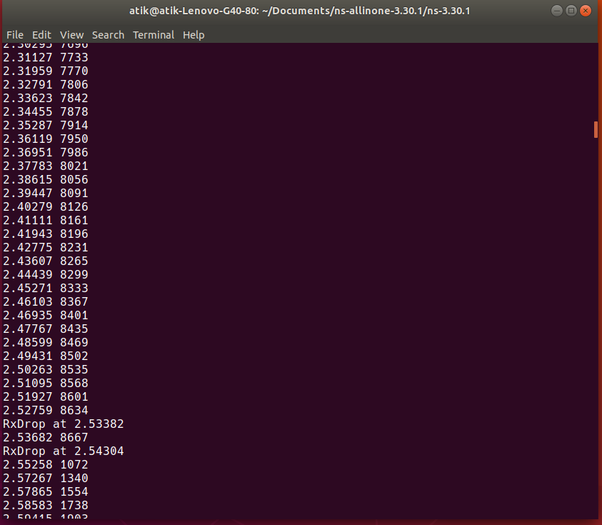

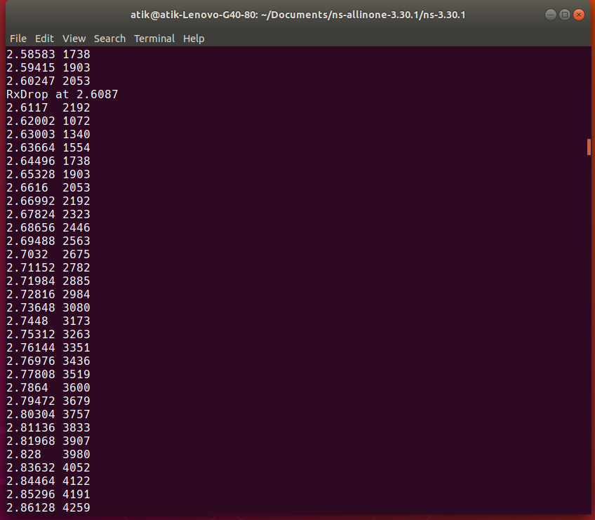
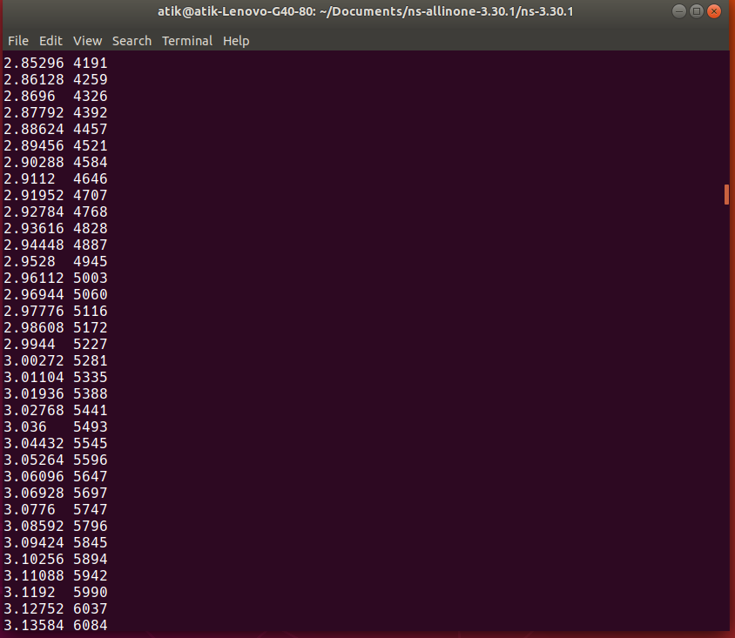

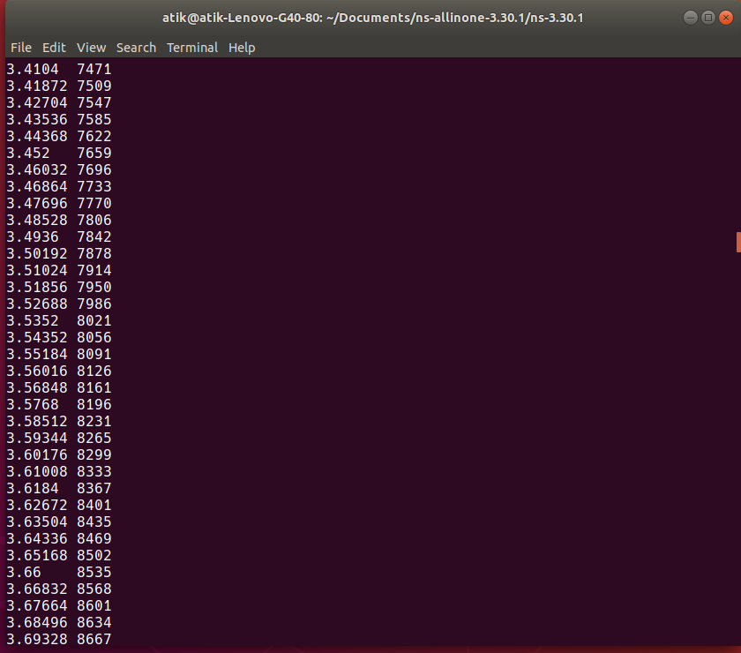

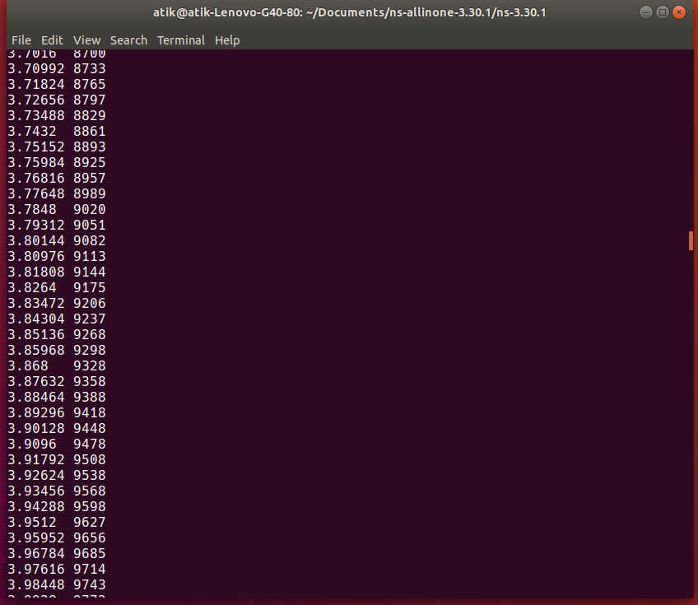
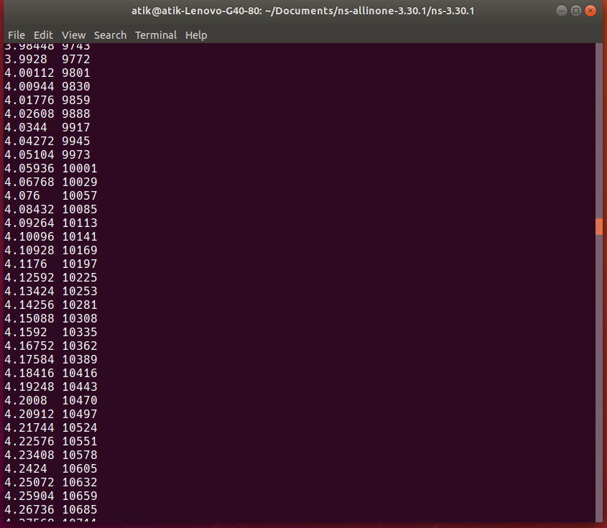

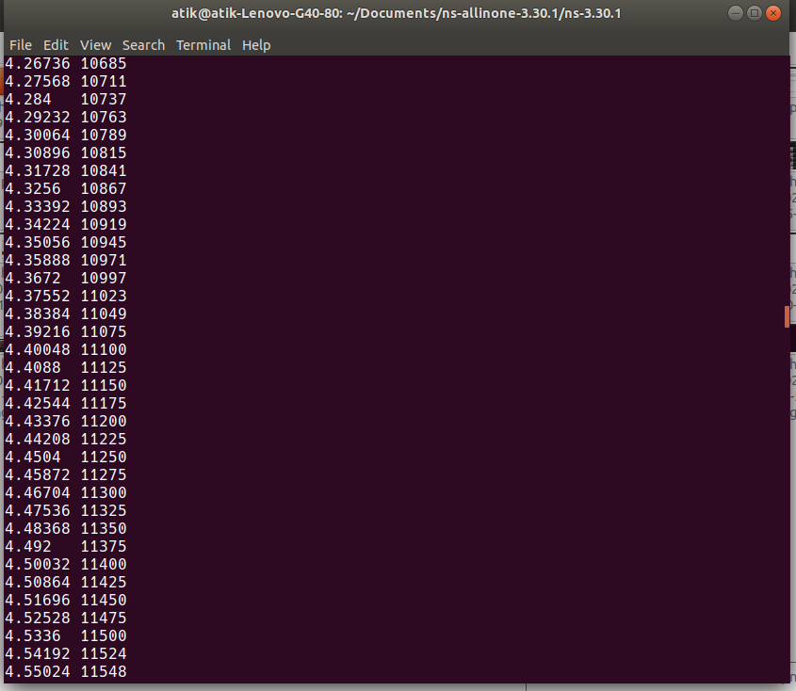
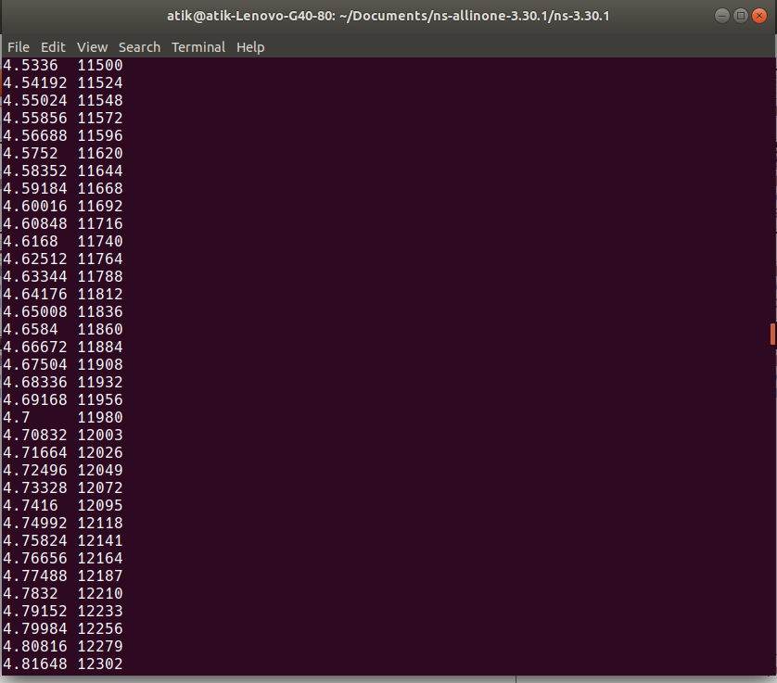

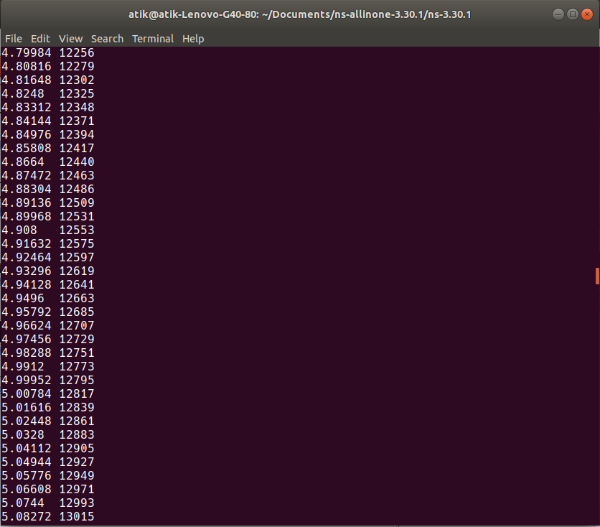
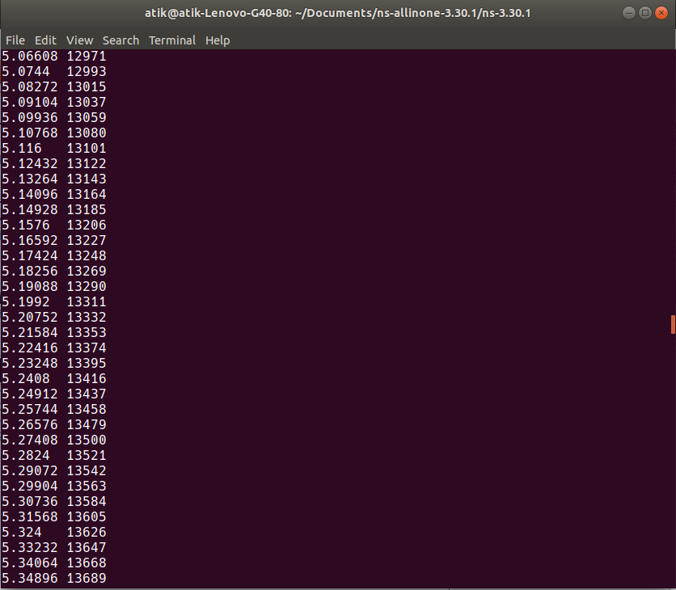

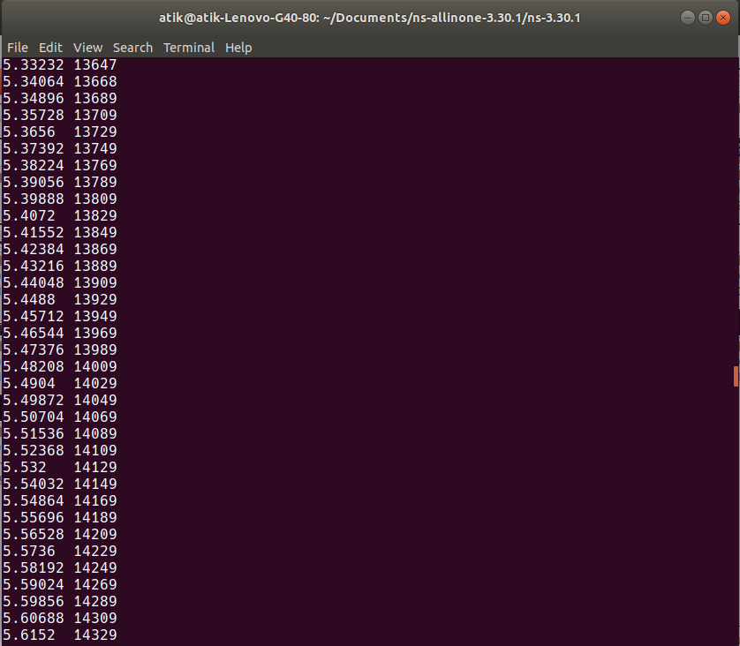
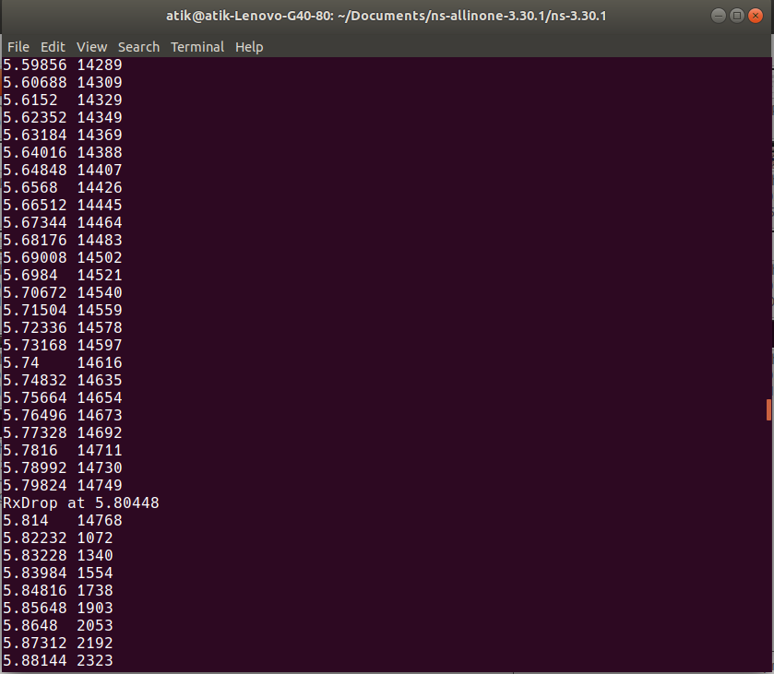

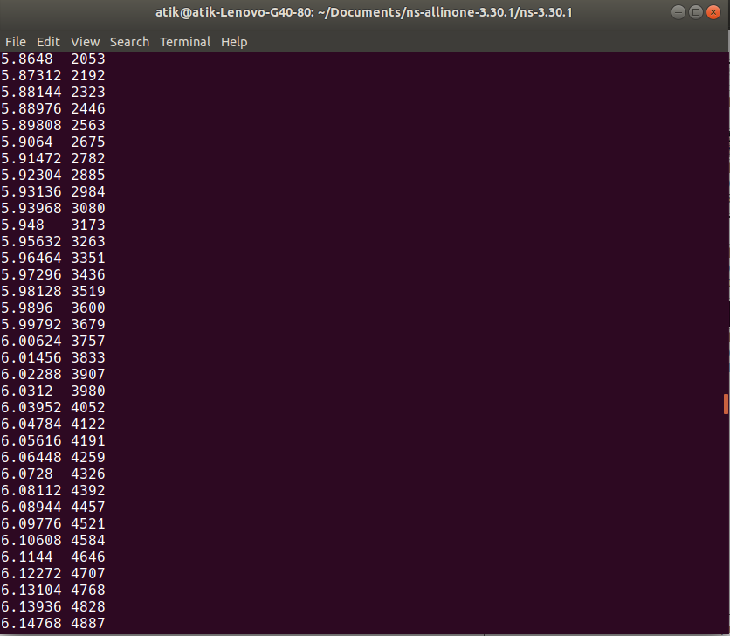
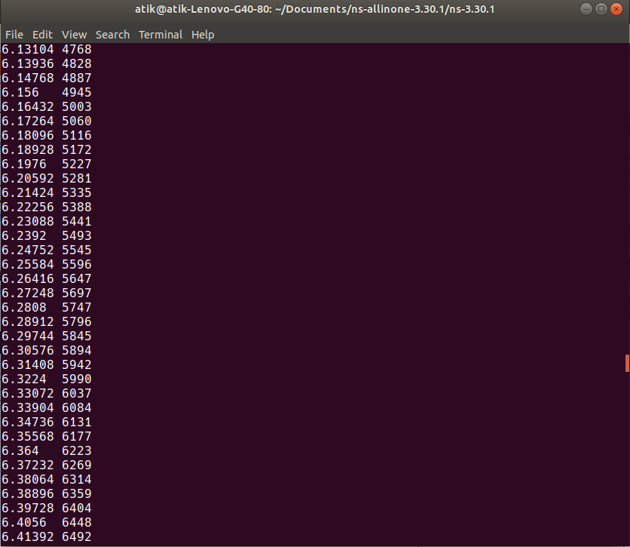

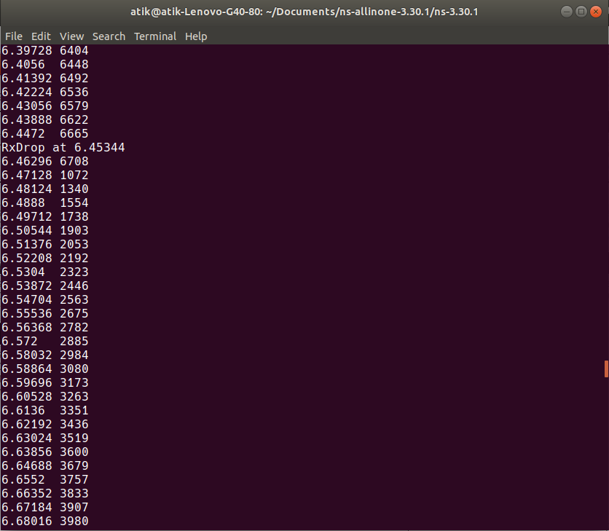
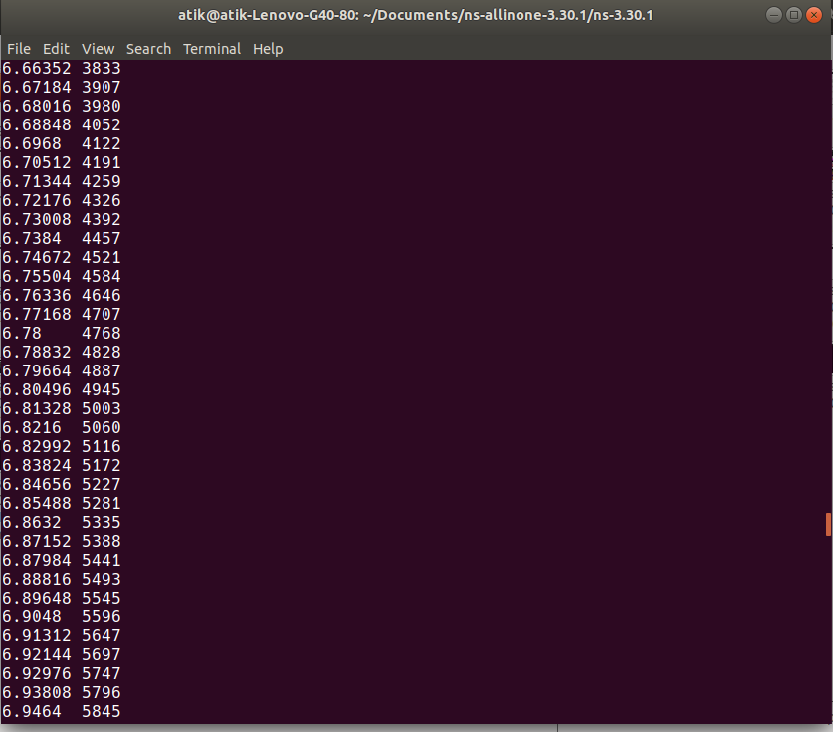

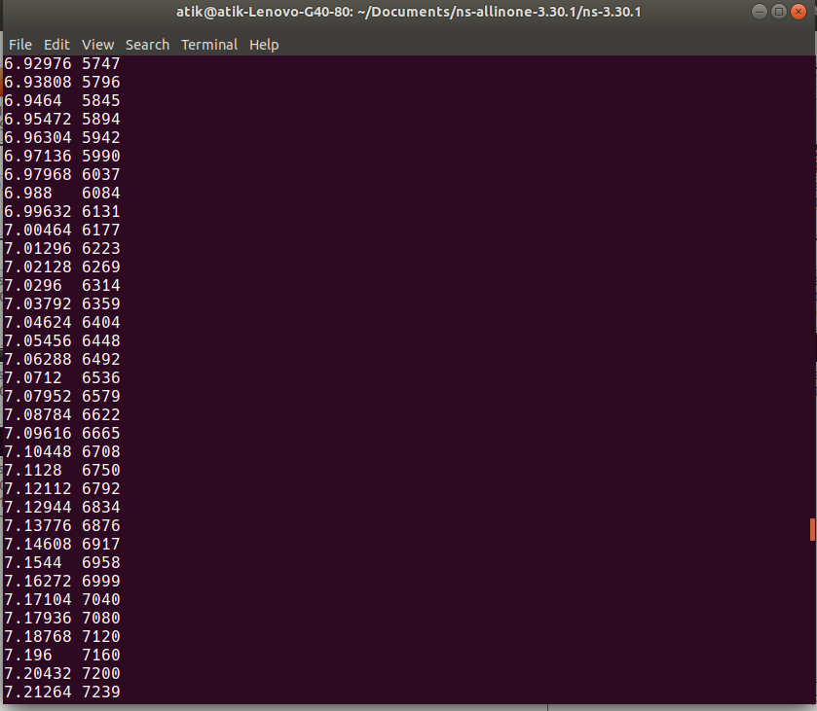
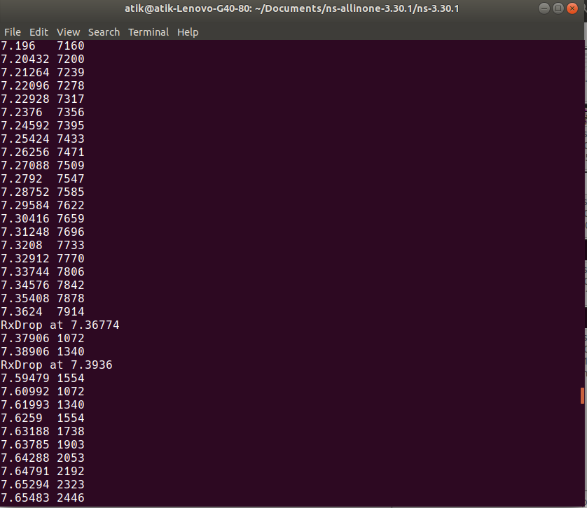

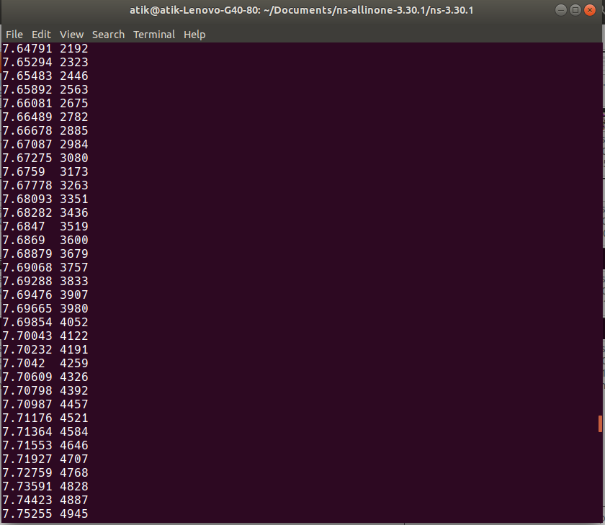
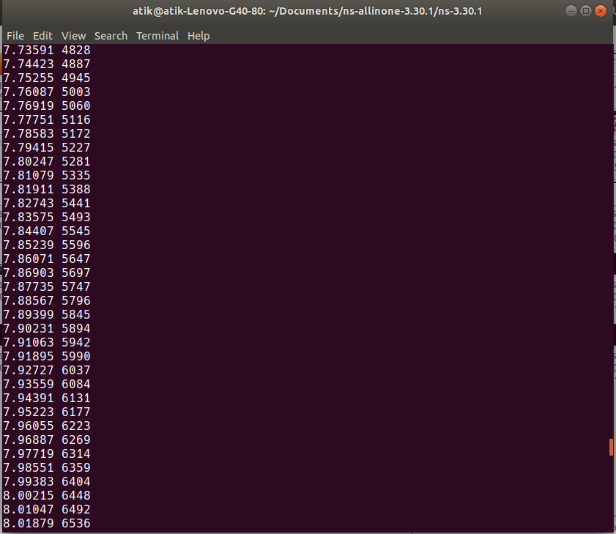

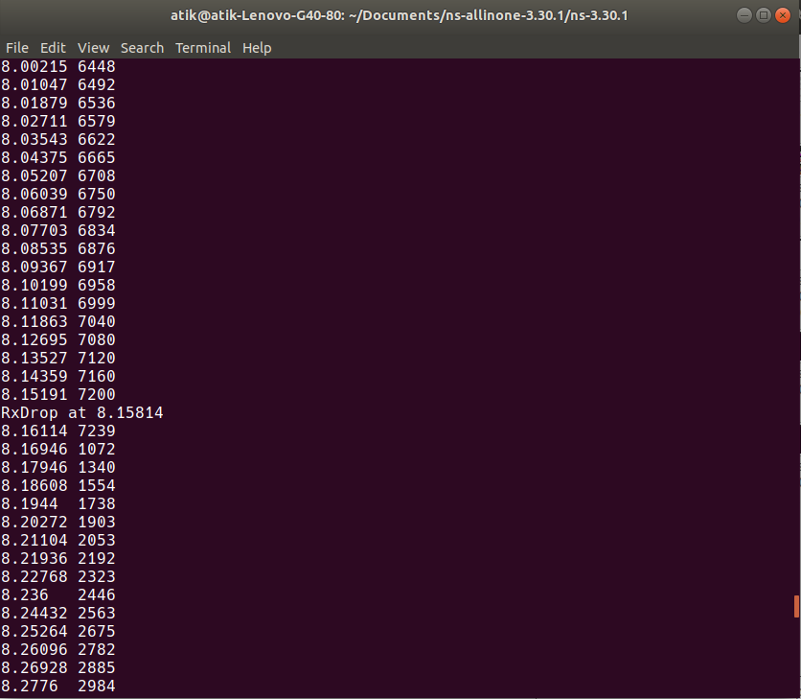
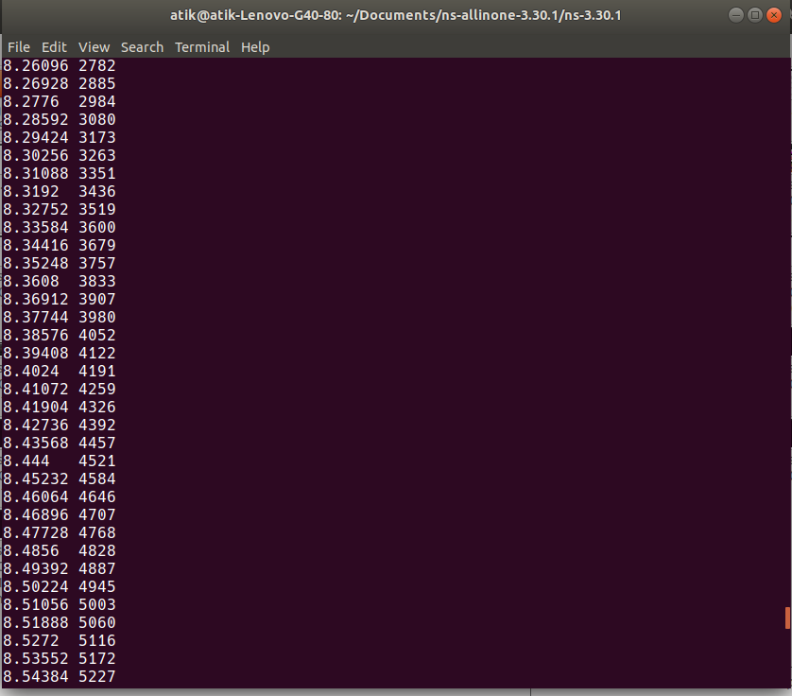

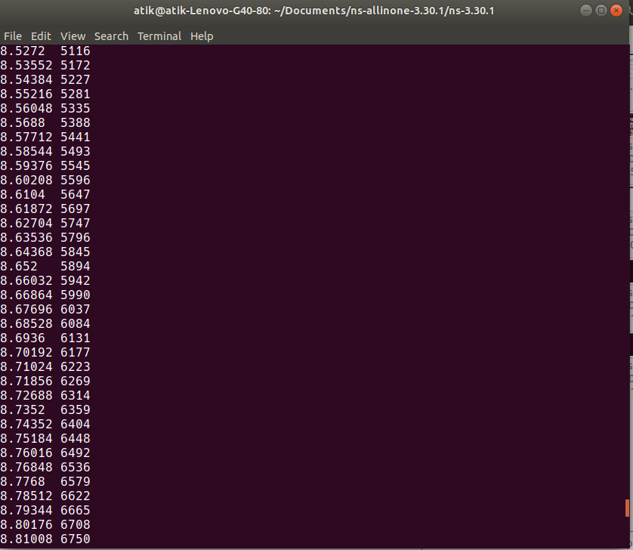
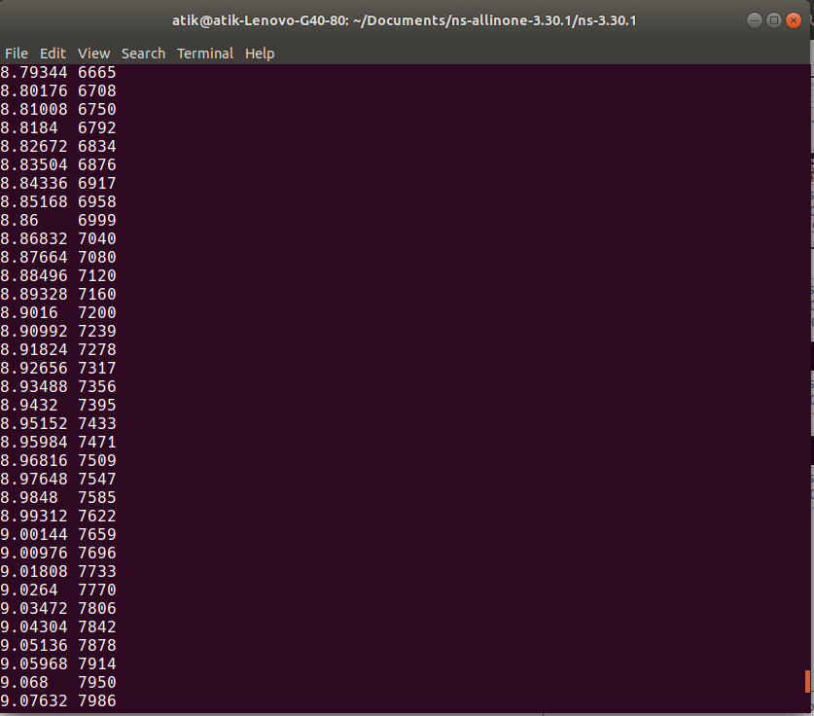

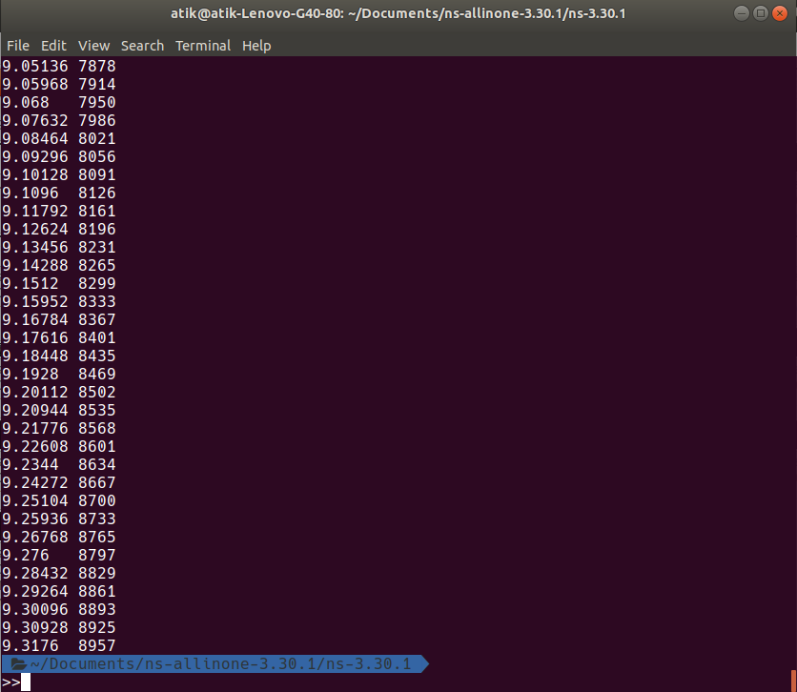

Conclusion:

Transmission Control Protocol (TCP) uses a network congestion-avoidance algorithm that includes various aspects of an additive increase/multiplicative decrease (AIMD) scheme, along with other schemes including slow start and congestion window, to achieve congestion avoidance. The TCP congestion-avoidance algorithm is the primary basis for congestion control in the Internet. Per the end-to-end principle congestion control is largely a function of internet hosts, not the network itself. There are several variations and versions of the algorithm implemented in protocol stacks of operating systems of computers that connect to the Internet.

